**PBIS Overview**

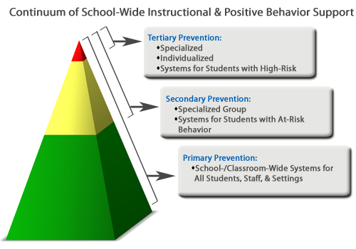

***Schoolwide PBIS has 3 key components:***

***Tier I***

***Universal support/Primary Prevention—Your classroom management system must be successful with at least 80-85% of the population. Provision of support to all students in a wide range of school settings in a proactive way to enable students to receive support and recognition.***

***\*Examples: School-wide Behavior Expectations***

***Paloma ticket store***

***Masters of Mindfulness***

***Student of the Month***

***Zones of Regulation***

***Paloma de Paz trimester Award***

***Tier II***

***Group support/Secondary Prevention—Supports for 10-15% of the population. Provision of support and intervention for students who have received universal support who require further intervention and support in order to experience success.***

***\*Examples: Behavior Contracts***

***Check in Check Out (CHICO)***

***Daily Self-Evaluation***

***Student Incident Report (SIR)***

***Zones of Regulation***

***Circulos de Paz***

***Tier III***

***Individual support/Tertiary Prevention—This is for the remaining 5% of the population. The most intensive support provided to students on an individual basis who have not had their needs adequately met through universal and group support because they require more intensive supports specifically tailored to their strengths, preferences, and unique needs.***

***\*Examples: Office Discipline Referral (ODR)***

***Counseling Referral***

***Coordination of Services Team (COST)***

***Functional Behavior Assessment (FBA)***

***Behavior Implementation plan (BIP)***